### Class Exercise #4 - The CSS Box Model

25 points

Instruction

1. Similar instruction to Class Exercise #1, #2, #3, etc. instructions.

2. Please use MS Windows 10 Snipping Tool to take screen shot of the following Tasks, **screen shot of the web browser not the HTML code from the video, make sure it is legible and readable screen shot.**

2. Please put your full name in the header.

3. Please do not modify this document to another format, keep as MS Word with .docx.

4. Submit this document to eCampus > Submit Your Assignment Here > Class Exercise #4 Submit Here. Refer to the syllabi for due date.

5. In this assignment you will create one html document:

* Task A – create **box.html** file.

6. In regards to your index.html page, **link the index page to the all webpages in step #5 above**, like you did for Class Exercise #1, the index.html to basic.html and link back from basic.html to index.html.

I shouldn’t use the back or forward-arrow buttons for navigation.

7. Please place all web pages under the Assignment column in your main index page, provide description to each under the Description column and include the date when you did this, when you link from your index page to these webpages and back to index.html, post your Class Exercise assignment, link it from your index.html page, please use the attribute target = “_blank” inside your anchor element, using FileZilla FTP account information, to your web directory. Please check on the web server to make sure all links are not broken.

8. File Structure – Please organize you file structure appropriately; with only one index.html file at the root of your directory, with several sub directories (022320, 023020, etc.), ClassExercises, ClassProject sub directories, and only one index.html file at this time.

Like this:

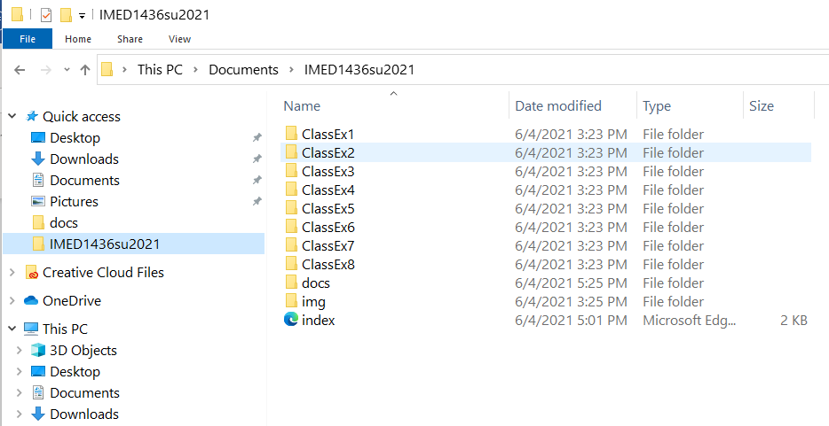

The file structure will vary from users to users, the above screen shot is only a recommendation.

**NOTE:** For all flex semesters or regular semesters, please do not create sub directories of dates, but put everything inside ClassEx4 sub directory.

NOTE: Your local directory should mirror the same file structure on the FTP web server.

-----------------------------------------------------------------------------------------------------------------------------------------

**The CSS Box Model**

All HTML elements can be considered as boxes. In CSS, the term "box model" is used when talking about design and layout.

The CSS box model is essentially a box that wraps around every HTML element. It consists of:

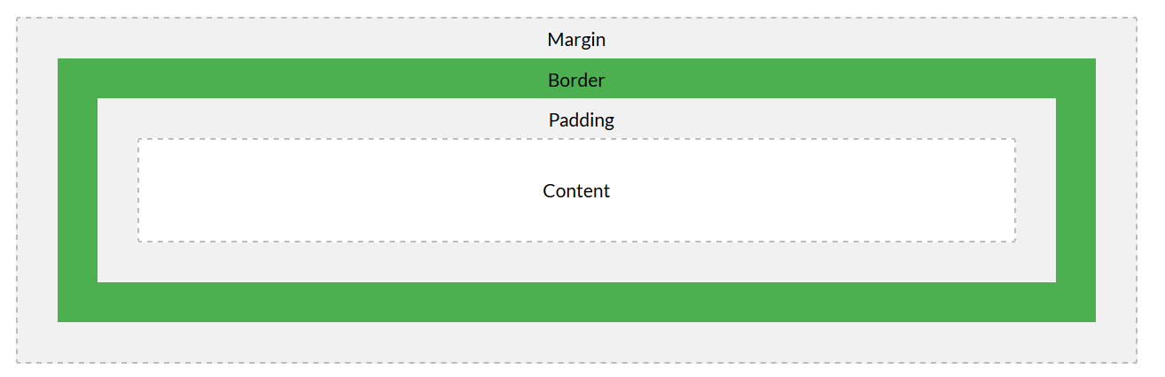

Explanation of the different parts:

* **Content** - The content of the box, where text and images appear
* **Padding** - Clears an area around the content. The padding is transparent
* **Border** - A border that goes around the padding and content
* **Margin** - Clears an area outside the border. The margin is transparent

The box model allows us to add a border around elements, and to define space between elements.

-----------------------------------------------------------------------------------------------------------------------------

Please install either one of the follow extensions to VS Code to preview your webpage, either

**Live Server:** <https://www.youtube.com/watch?v=KNKvi2qLPrg>

**OR**

**Open in Browser:** <https://www.youtube.com/watch?v=epUkmCMN4oc>

-----------------------------------------------------------------------------------------------------------------------------

**Task A:**  **Box.html**

1. Please watch this video:   
  
 CSS Box Model - Part 1: <https://www.youtube.com/watch?v=GHWpqQYCN1Y>

2. Create sub directory with today’s date, inside this subdirectory, create new **box.html** document with the proper HTML elements and tags, save it and open in web browser. Using the Snipping Tool, take screen shot of the Model Box in the web browser, **copy/paste below**:

---------------------------------------------------------------------------------------------------------------------------------------

**Width and Height of an Element**

In order to set the width and height of an element correctly in all browsers, you need to know how the box model works.

**Important:** When you set the width and height properties of an element with CSS, you just set the width and height of the content area. To calculate the full size of an element, you must also add padding, borders and margins.

**Task B: continue with Box.html file**

1. Please watch this video:

CSS Box Model - Part 2: <https://www.youtube.com/watch?v=qaaUKU1YZd4>

Here is the calculation of the **klematis4_big.jpg** flower, 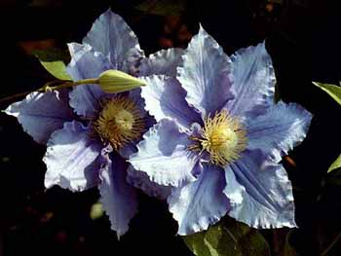

klematis4_big.jpg

Download from eCampus > Class Exercises > Class Exercise #4 folder, right mouse on the image and select “Save Image As”, into your img sub directory.

The width of the klematis4_big.jpg image is **350px**

320px (width)  
+ 10px (left + right padding, means two times for both padding, that’s 20px)  
+ 5px (left + right border, means two times for border, that’s 10px)  
+ 0px (left + right margin)  
**---------**

**350px**

The total width of an element should be calculated like this:

Total element width = width + left padding + right padding + left border + right border + left margin + right margin

The total height of an element should be calculated like this:

Total element height = height + top padding + bottom padding + top border + bottom border + top margin + bottom margin

2. Using the Snipping Tool, take screen shot of the new klematis4_big.jpg flower with Model Box in the web browser from the video, **copy/paste below**:

----------------------------------------------------------------------------------------------------------------------------------------------

**Task C:** Go to eCampus > Class Exercises > Class Exercise #4 folder, download the compress flowers.zip and extract this file to the **flowers** folder, right mouse button and select Extract All to extract, inside this folder you will all sorts of flowers from my garden. In this task, you will repeat the same task as Task B on a different flower.

CSS Box Model – Part 3: <https://www.youtube.com/watch?v=ojDlmNjbAXA>

1. Select one of the images that you want to use, copy and paste this image into your img sub directory.

2. Insert this image into the **box.html** file and block comment all the previous HTML and internal CSS codes, keep just the basic html skeleton code.

3. Create a text box with the same width as the image that you selected with internal CSS code.

4. Using the Snipping Tool, take screen shot of the new box.html file with the selected flower image with Model Box in the web browser, copy/paste below:

---------------------------------------------------------------------------------------------------------------------------------------

**Task D: Finishing Touch - RECAP**:

After you watch all segments and complete all Tasks A, B and C (no video), your last task for task is to update your current index web page with the content we currently complete for this week, please refer to the course syllabi schedule to assistance. You need to include the follow to the index.html.

* link to Class Exercise #4 from your index page with a new tab open (recall target = “_blank”).
* Make sure all links work before I grade, points will be deducted for broken links.
* All .html screen shots are for all the tasks are taken in the web browsers, not the html code.
* All webpage from this assignment must be link to and from the index.html.
* For the rest of the semester, we will be using Visual Studio Code, please do not use Notepad or any other Text Editor for this course.

**Please copy and paste your webpage URL in browser below:**

**http://www.mmlab2.rlc.dcccd.edu/imed1416-83840/web8520**

**(NOTE: Please do not copy and paste your local drive path, recalled that I provided this URL with your FTP account information)**

**And**

**Please upload this document to eCampus > Submit All Assignment Here > Class Exercise #4 Submit Here** before due date!

Thanks, Dan.